

2017 MALAWI SCHOOL CERTIFICATE OF EDUCATION MOCK EXAMINATION

MATHEMATICS

PAPER II

(100 marks)

MOCK
Subject Number: M131/II
Wednesday, 5th April Time Allowed: 2 hrs 30 mins
08:00 – 10:00 pm

FORM FOUR

Instructions
Question  Number | Tick if  answered | Do not write in these columns

1

2

3

4

5

6

7

8

9

10

11

12

- This paper contains 19 printed pages. Please check.
- Write your Names at the top of each page.
- Answer all the six questions section A and any three questions from section B.
- The maximum number of marks for each answer is indicated against each question.
- In the table provided on this page, tick against the question number you have answered.
- Calculators may be used.
- All working must be clearly shown.
- At the end of the examination, hand in your paper to the invigilator.

© 2017 UNIQUE EXAMS Turn over
Section A (55 marks)
Answer all the six questions in this section.

1. a. Without using a calculator or four figure tables, simplify
$$\frac{3\sqrt{5}-\sqrt{2}}{2\sqrt{5}+3\sqrt{2}}$$

(4 marks)
b. Factorize completely ${4x}^{2} -8xy - {5y}^{2}$

(4 marks)

2. a. Given that $\log_{a}{2= 0.668 }$and $\log_{a}{3= 0.884}$, evaluate
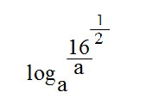

(4 marks)
b. Find the equation of the parabola with a turning point (-1, 5) and passes through point (1, 13).

(4 marks)
3. a. Solve for “x” in the following equation:
$$\log_{4}x^{2}+ 15x-18 =2+\log_{4}{x}-{1}$$

(4 marks)
b. Simplify $\frac{{4x}^{2}- 2x}{x - 2}÷\frac{x(2x-1)}{x^{2}- 5x+6}$

(5 marks)
4 a. Solve the equation ${2x}^{2} - 3x =1$, giving your answer correct to two decimal places.

(4 marks)
b. If $m{(mt-q)}^{-1}= 1$, express “m” in terms of q and t.

(5 marks)

5 a. In figure 1, AT is a tangent of the circle centre O. Angle OXT $=$ 31⁰ and AOX is a straight line.
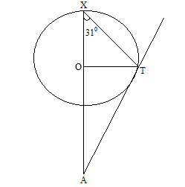

Figure 1

Calculate angle OAT.

(5 marks)
b. The remainder when $x^{3}- {3x}^{2}-2x + a$ is divided by $x + 2$ is twice the remainder when the same expression is divided by$x - 3$. Find the value of a.

(6 marks)
6 . a. Solve the following simultaneous equations
$x + y = 9$
$x^{2}– 3xy +{2y}^{2} = 0$

(5 marks)

b. Figure 2 is a graph showing the equation of line AB in the form $y = mx+ c$.
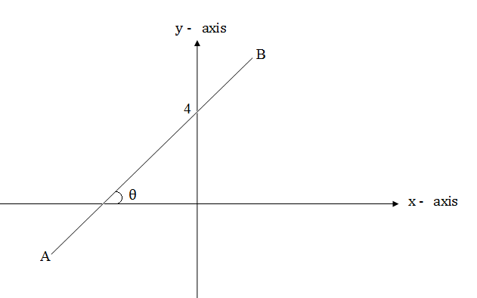

Figure 2
Given that tan $θ =\frac{1}{2}$, find the equation of line AB in the form $y = mx+ c$ and the coordinates of the x- intercept for the graph.

(6 marks)
Section B (45 marks)

Answer any three questions from this section.
7. a. Two white balls and six red balls were placed in an opaque bag. A ball was taken at random from the bag. Its color was noted and the ball was replaced. A second ball was then drawn from the bag. With the help of a tree diagram, calculate the probability that the balls were
(i). both white
(ii) of different color.

(7 marks)
b. Figure 3 PQRS is a rectangle, angle TSR = 36⁰, angle SRT = angle TRQ = 90⁰,
PQ = 15 m and PS = 8 m.
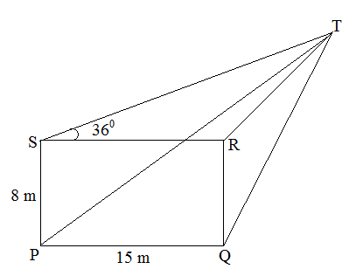

Figure 3

Calculate:
- the length of TR
- the angle between PT and the rectangle PQRS, giving your answer correct to one decimal place.

(8 marks)
8. a. In a geography exam, the percentage marks of 50 boys were:
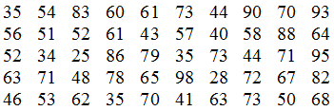

- Construct the histogram, taking class-intervals $21-30, 31-40,$…, …, …$91-100$.
- What is the modal class?
- Find the mean mark for the test.

(9 marks)
b. MN and P are three points on the circumference of circle, centre O. The chord MP is produced to Q so that PQ = PN. Prove that the angle MON is four times angle MQN.

(6 marks)
9. a. A varies partly as B and partly as the square root of B. When$B=4$, $A=22$, when $B=9$, $A=42$. Find A when $B=25.$

(9 marks)
b. Figure 4 shows a triangle ABC in which $AB=4$ cm, $AC=10$, angle ABC=90⁰ and the bisector of angle BAC cut BC at P.
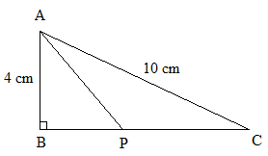
Figure 4
Calculate:
(i) angle BAP;
(ii) the length of BC and hence PC.

(6 marks)
10. a. Suppose you have K1500 to spend in a shop. You have decided to:
- divide the money between buying bottles of cooking oil at K150 each and tablets of soap at K60 each..
- buy at least 5 tablets of soap.
- spend more on cooking oil than soap by more than K300.
(i) If x and y represent the number of bottles of cooking oil and tablets of soap respectively, write down the three inequalities which x and y must satisfy the above three conditions.
(ii) Using a scale of 2 cm to represent 2 units on the x-axis and 2 cm to represent 5 units on the y-axis, draw a region bounded by the inequalities obtained in (i) above by shading unwanted area.

(iii) For which values of x and y is x + y the greatest?
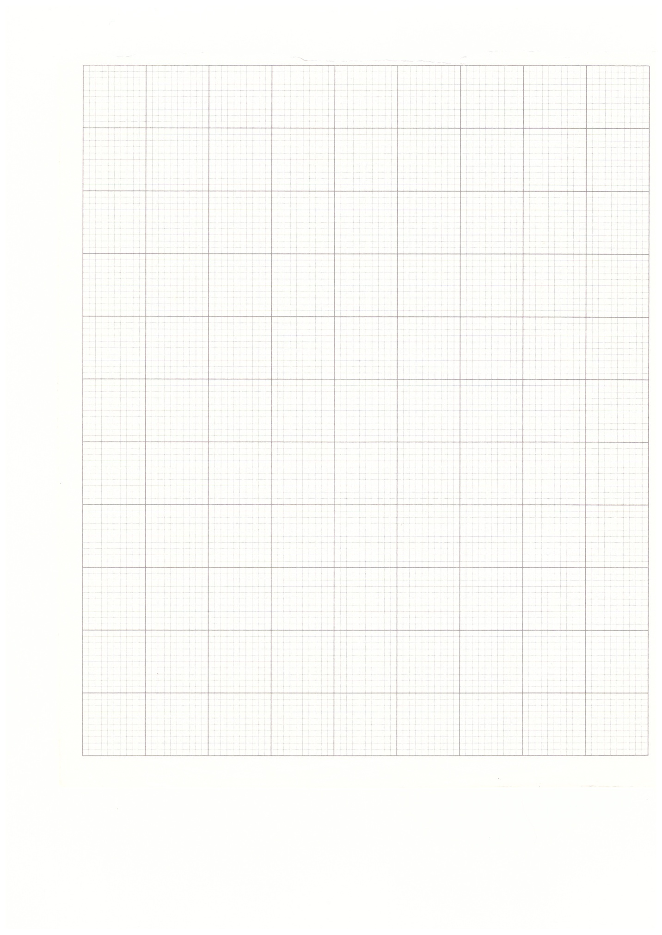
(9 marks)
b. Using a ruler and a pair of compasses only, construct in the same diagram:
(i) a circle centre O of radius 3 cm.
(ii) a point R outside the circle such that $OR=10 cm$.
(iii) a tangent TR to the circle.

(6 marks)
11. a. (i) Copy and complete the table of values for the equation $y=x\left(x^{2}-x-6\right).$
x | -3 | -2 | -1 | 0 | 1 | 2 | 3 | 4
y | -18 | 0 |  | 0 | -6 |  | 0 | 24

(ii) Using a scale of 2 cm to represent 1 unit on the x-axis and 2 cm to represent 5 units on the y-axis, draw the graph of $y=x\left(x^{2}-x-6\right).$
(iii) Use your graph to solve the equation: $y=x\left(x^{2}-x-6\right)+ 5=0.$

(9 marks)

b. The sum of three positive terms of a geometric progression (GP) is 52. The square of the second term is four times the third term. Find the three terms.

(6 marks)
12. a. In a class of 50 students, each of the students ate at least one of the following types of fruits bananas, mangoes and oranges. It is found that:
- $x+1$ student ate all the three types of fruits.
- 9 students ate mangoes and oranges only.
- 8 students ate bananas and mangoes only.
- 5 students ate bananas and oranges only.
- x students ate bananas only.
- $x+4$ students ate oranges only.
(i) Illustrate the information using a Venn diagram.
(ii) Find the number of students who ate mangoes.

(9 marks)
b. Figure 5 below shows a circle with tangent TP, RP and centre O. Use it to answer the questions that follow.
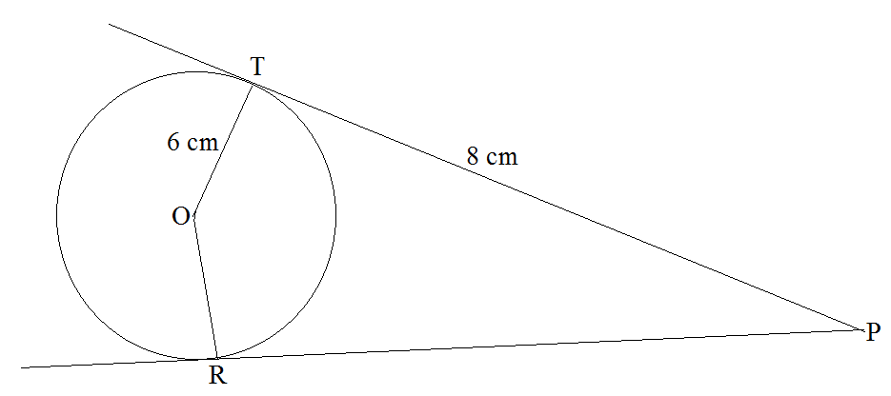
Figure 5

Calculate the:
(i) angle TPR
(ii) angle TOR.

(6 marks)

END OF QUESTION PAPER

